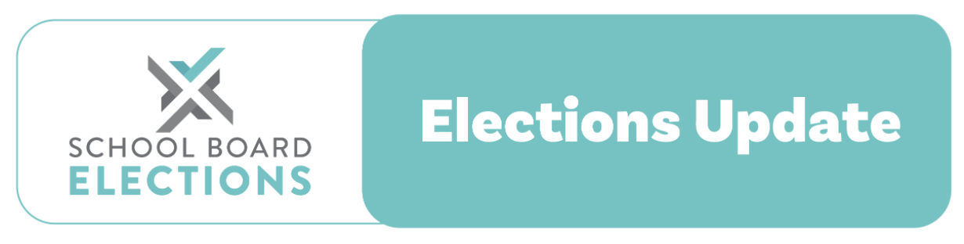

25 May 2022

2022 school board triennial elections
Regulation Changes Commencing 9 June 2022

Kia ora
The Ministry of Education has released a new updated set of regulations to enable the introduction of electronic voting, and other changes, for this year’s triennial school board elections in September.
The updates to the Education (Board Elections) Regulations 2000 (SR 2000/195), which will officially come into effect on 9 June 20222, require your board to choose from one of the following options:
- The board appoints an accredited provider as their returning office to run electronic elections
- The board appoints a returning officer to engage with an accredited provider and use their services to run electronic elections.
- The board appoints a returning officer who will run paper elections and will not offer electronic elections.
To make the right decision for your school we recommend your board discuss which method you would prefer to run your elections and choose an election date. Once you have decided your Returning Officer or Accredited Provider will be able to confirm this choice when they complete the Returning Officer Registration form.
Election dates and timelines
For staff and parent elections, the supplementary roll will close 37 days before election day (rather than 35 days as previously), and nominations will close 35 days before election day (rather than 33 as previously). See the new timetable below, based on the recommended election date of Wednesday 7 September. Boards still have the flexibility to hold their election anywhere from 5 – 23 September. We will notify you when our Election Planner tool, which we’re developing, is updated for these changes to schedule.

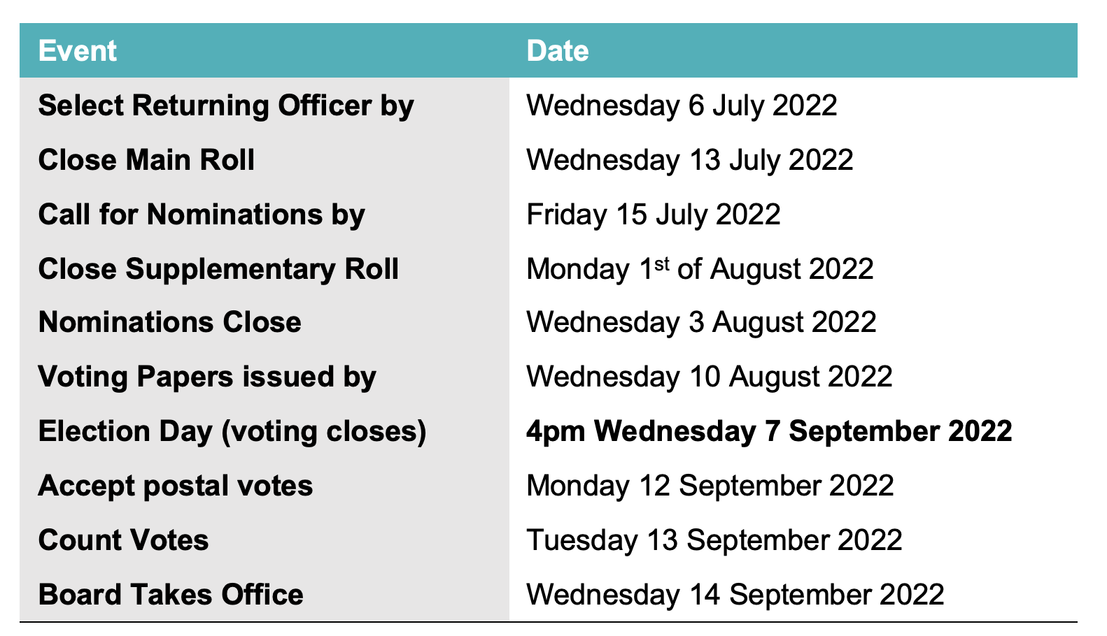

Student Elections
Student Elections have been shortened to a 31 - day timetable. Based on a recommended election date of Wednesday 21 September you can see the timetable below, which includes dates for election milestones. Boards have the flexibility to hold the student election throughout September. NZSTA will notify you when a Student election planner tools is available for use.

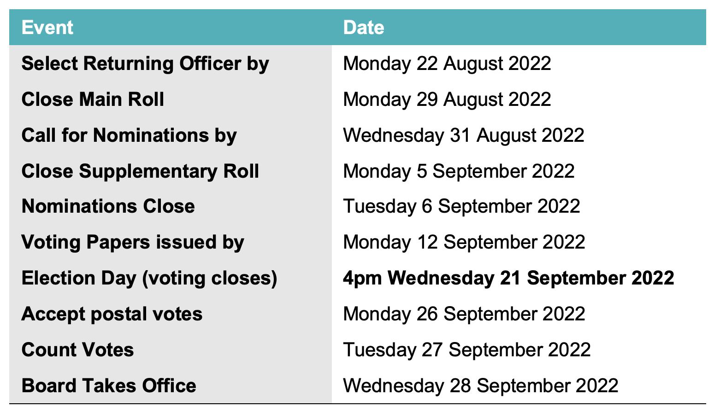

Scrutineers
Scrutineers for electronical elections will now have the added role of recounting the electronically cast votes in replacement of observing the and examining the opening of envelopes and counting examining envelopes and voting forms.
Reminder of changes from the Education (Board Elections) Regulations 2020
If your school hasn’t held a school board election since 2019, you may not be aware of several other changes introduced to the School Board Election Regulations in 2020, which still apply:
- The elections timetable changed to a 63 day timetable for all elections, including by-elections, for a parent, staff or student vacancy. The timetable cannot be shortened, and the 37-day timeframe can no longer be used.
- To fill a casual vacancy for a parent representative, there is now no longer a requirement that this must be done within 6 weeks. The requirement is to hold a by-election, which is a 63-day process, or to fill the vacancy by using the selection process.
- The notice calling for nominations no longer needs to be published in the local newspaper (but it still can be). E.g. it can now be placed on the school website or in the school newsletter.
- Nomination materials can now be emailed out or personally delivered or posted.
- There are changes to the vote invalidation rules: voting forms are now no longer invalid for the reason they were not returned in the envelope supplied. They are also now not deemed invalid if there are two sets of voting papers in one envelope.
- The election results (voting or non-voting) no longer need to be published in the local newspaper (but they still can be). All voters on the roll should be able to access a copy of the results but it is up to the board to decide how best to communicate with their school communities and their wider community. E.g. the results can now be announced via the school newsletter, school website, school Facebook page, whānau hui,and community noticeboard.
For further information contact the NZSTA Elections Team.
Our team is here to support you and your board during the school board elections:
- School Board Elections website schoolboardelections.org.nz/returning officers/
- NZSTA Election Advice Line 0800 ELECTION (0800 353 284)
- Email electionsadvice@nzsta.org.nz



